OB II Cardiac Assignment:
Winter 2020

Name:

Please define the following terms:
Atresia: Condition in which a body orifice or passage in the body is abnormally closed or absent.
Arrhythmia (and note the three most common): Irregular heart beat
Bradycardias-heart rate below the normal limits of normal- <100bpm
Tachycardia-heart rate is above the normal limit for normal >180 bpm
PAC or premature atrial contraction- atrial contractions occurring out of sync with ventricular contractions.
Stenosis: Abnormal narrowing in a blood vessel or other tubular organ or structure.
Hypoplastic: Underdevelolpment or incomplete development of a tissue or organ. Technically refers to an inadequate or below normal number of cells. Hypoplasia is similar to aplasia bus less severed
Atrophy: The wasting away of already existing cells.
Dysplastic: Abnormality of development or an epithelial anomaly of growth and differentiation.

Please Label the following diagrams of congenital cardiac anomalies with their appropriate names:

- Ventricular Septal Defect

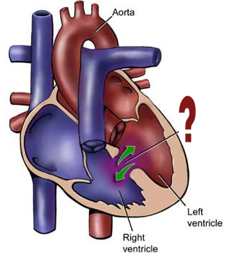

- Double outlet right ventricle
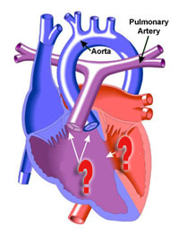
- Truncus Arteriosus

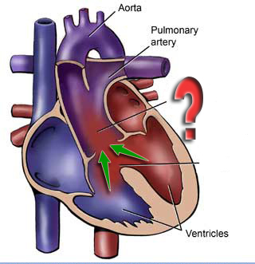
- Ebsteins Anomaly
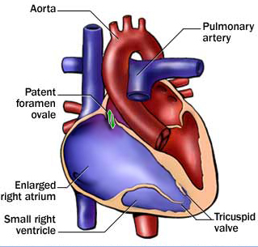

- Atrioventricular Septal Defect
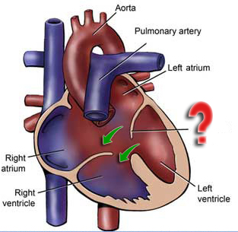

- Tetrology of Fallot
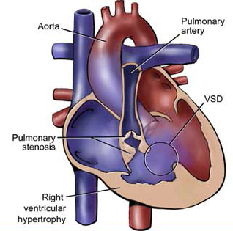

- Hypoplastic Left Heart

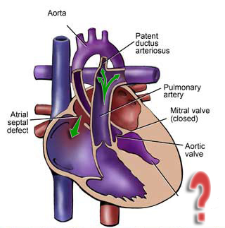
- Transposition of the Great Vessels

