Assignment 1
DMS 333

Normal First Trimester/Conception

Please label the following illustrations.

1.___Fertilization________________________

2.___Zygote________________________

3.___Morula________________________

4.____Blastocyst_______________________

5.____Implantation_______________________

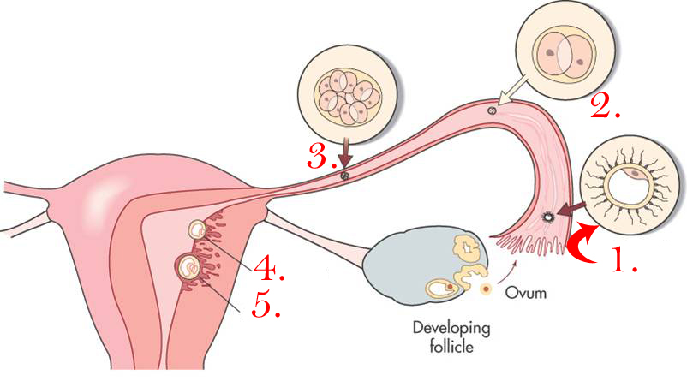

Development of amnion, chorion, yolk stalk, and embryo.

1.___Uterine Cavity________________________

2.__Chorion_________________________

3.___Amniotic Cavity________________________

4.___Yolk Stalk Remnant or Umb Cord________________________

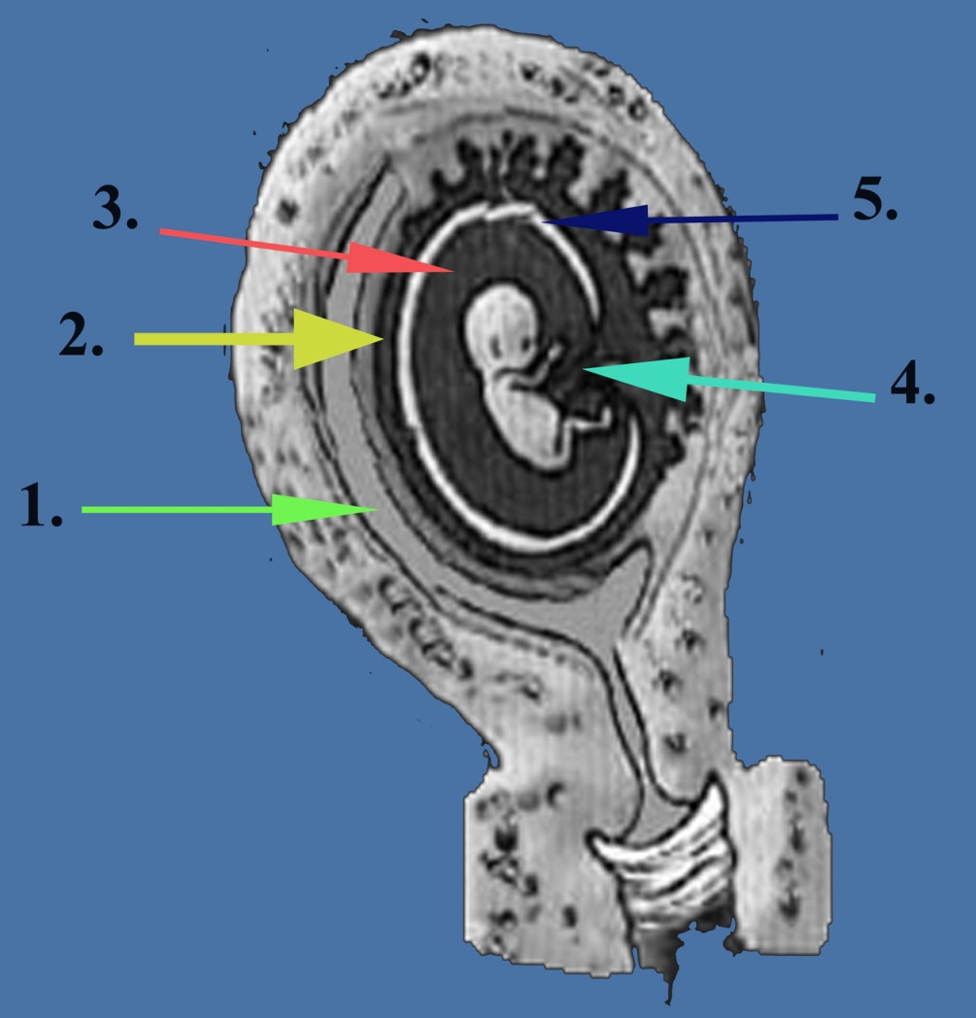
5.___Amniotic Membrane________________________

First Trimester Thoughts

- Describe the sonographic appearance of an early intrauterine pregnancy.
During the fifth week of embryonic development the intrauterinepregnancy(IUP) can be visualized sonographically. It appears as a 1- to 2-mm sac with an echogenic ring having a sonolucent center. The anechoic center represents the chorionic cavity. The circumferential echogenic rim seen surrounding the gestational sac represents trophoblastic tissue and associated decidual reaction. These include a round or oval shape; a fundal position in the uterus, or an eccentrically placed position in the middle portion of the uterus; smooth contours; a decidua wall thickness greater than 3 mm; and a yolk sac with an MSD greater than 10 mm and an embryo with an MSD greater than 18 mm. The gestational sac size grows at a predictable rate of 1 mm per day in early pregnancy.

- Describe what happens to the bowel migration in the first trimester.
The anterior abdominal wall is developed by 6 weeks of gestation from the fusion of four ectomesodermal body folds. Simultaneously, the primitive gut is formed as a result of the incorporation of the dorsal yolk sac into the embryo. The midgut, derived from the primitive gut, develops and forms the majority of the small bowel, cecum, ascending colon, and proximal transverse colon. Since the midgut is in direct communication with the yolk sac, amniotic cavity expansion pulls the yolk sac away from the embryo forming the yolk stalk. As amniotic expansion occurs, the midgut elongates faster than the embryo is growing, causing the midgut to herniate into the base of the umbilical cord. Until approximately 10 weeks gestation, the midgut loop continues to grow and rotate before it descends into the fetal abdomen at about the eleventh week.

- What is the purpose of the secondary yolk sac?
The secondary or sonographic yolk sac has essential functions in embryonic development, including: 1. provision of nutrients to the developing embryo;
2. hematopoiesis; and 3. development of embryonic endoderm, which forms the primitive gut.

- How is the mean sac diameter determined?
Sonographically, the gestational sac size or mean sac diameter is determined by the average sum of the length, width, and height of the gestational sac. These measurements are obtained in both sagittal and coronal/semicoronal sonographic planes. When measuring the mean sac diameter, the sonographer should only measure gestational sac fluid space, not including the echogenic decidua.

- Describe the relationship between the sonographic findings and quantitative serum hCG levels in early pregnancy.
An intimate relationship between the sonographic findings and quantitative serum hCG levels normally exists during early pregnancy. Gestational sac size and hCG levels increase proportionately until 8 menstrual weeks, at which time the gestational sac is approximately 25 mm MSD and an embryo should be easily detected by either transabdominal or endovaginal sonography. After 8 weeks, hCG levels plateau and subsequently decline, while the gestational sac continues to grow.

