Assignment 1
DMS 333

Normal First Trimester/Conception

Please label the following illustrations.

1.___________________________

2.___________________________

3.___________________________

4.___________________________

5.___________________________

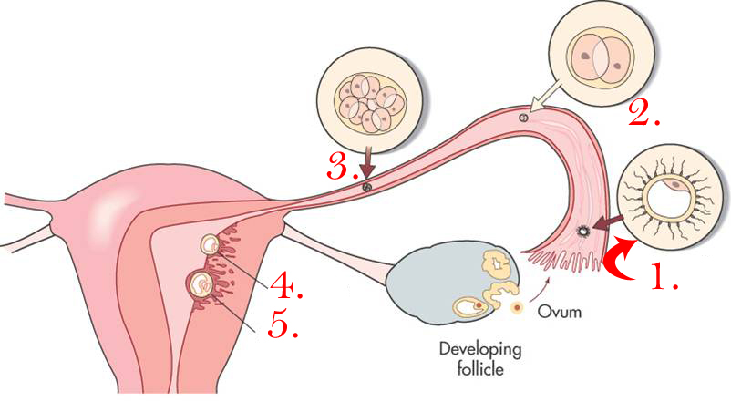

Development of amnion, yolk sac, and embryo.

1.___________________________

2.___________________________

3.___________________________

4.___________________________

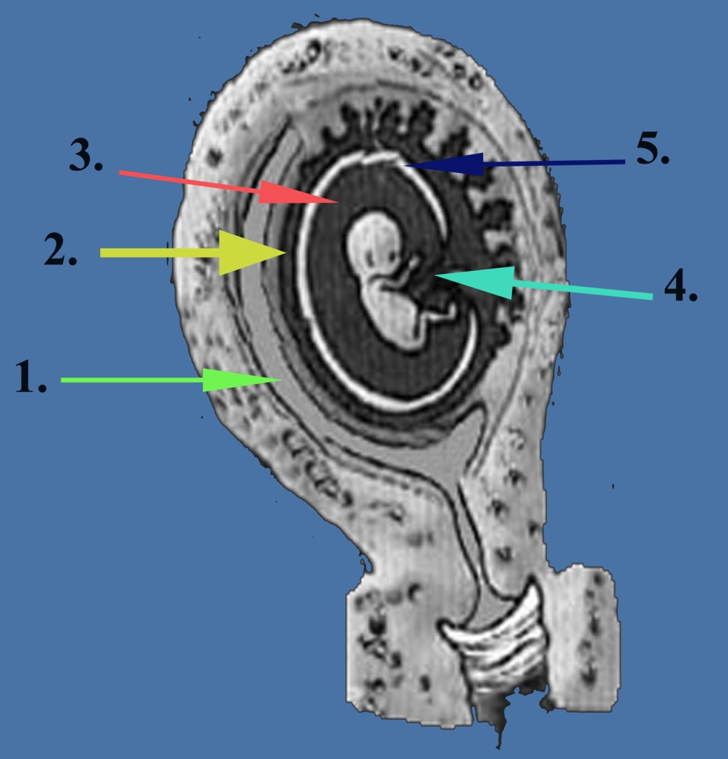
5.___________________________

First Trimester Thoughts

- Describe the sonographic appearance of an early intrauterine pregnancy.

- Describe what happens to the bowel migration in the first trimester.

- What is the purpose of the secondary yolk sac?

- How is the mean sac diameter determined?

- Describe the relationship between the sonographic findings and quantitative serum hCG levels in early pregnancy.

