OB II Cardiac Assignment:
Spring 2020

Name:

Please define the following terms:
Atresia:

Arrhythmia (and note the three most common):

Stenosis:

Hypoplastic:

Atrophy:

Dysplastic:

Please Label the following diagrams of congenital cardiac anomalies with their appropriate names:

1.

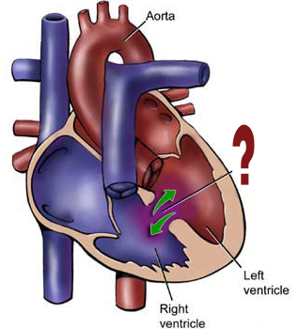

2.
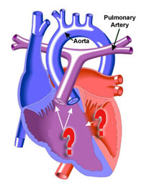
3.

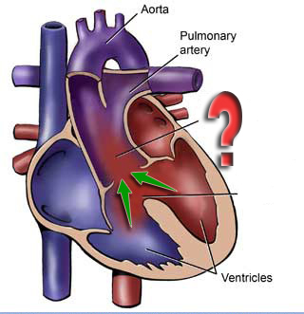
4.
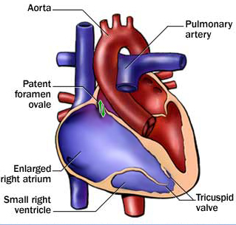

5.
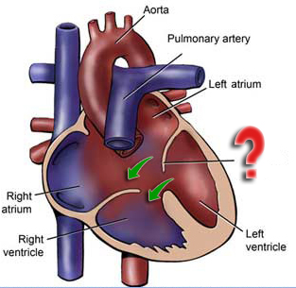

6.
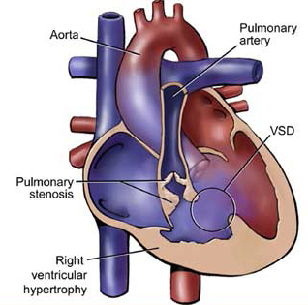

7.

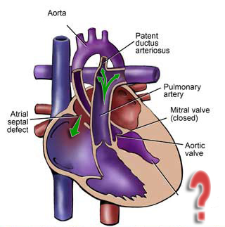
8.

