Week 6
Fetal Face and Neck
DMS 333

Instructions: This week I would like you to use your creative side to draw the following anomalies or body part, of the fetal face or neck. Please draw your images in the same planes as a sonographer would use, to document the anomaly or normal anatomical body part, during the sonographic evaluation.

- Cerebellar Plane

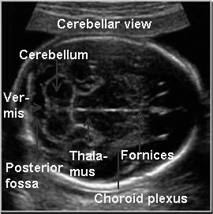

- Hypotelorism with caliper measurement
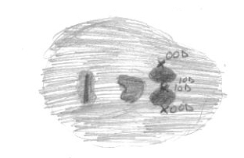

- BPD/HC Plane

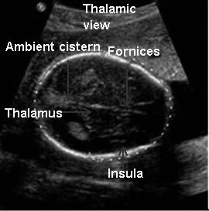

- Coronal image of upper lip and nostrils

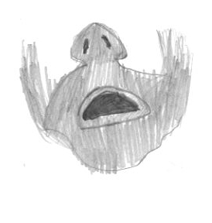

- Profile

